Lab 01 - Manage Azure Active Directory Identities

* Task 1: Create and configure Azure AD users.
  + In this task, you will create and configure Azure AD users.

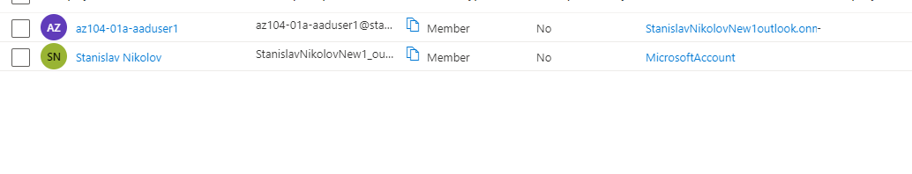

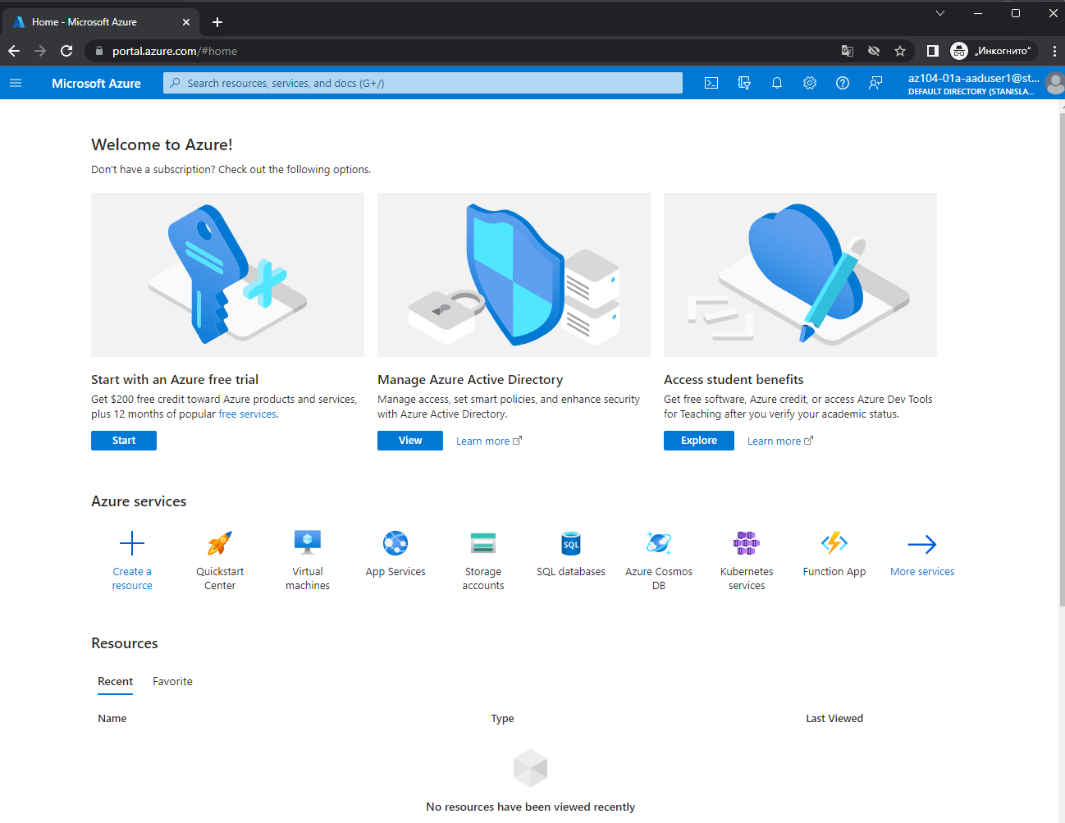

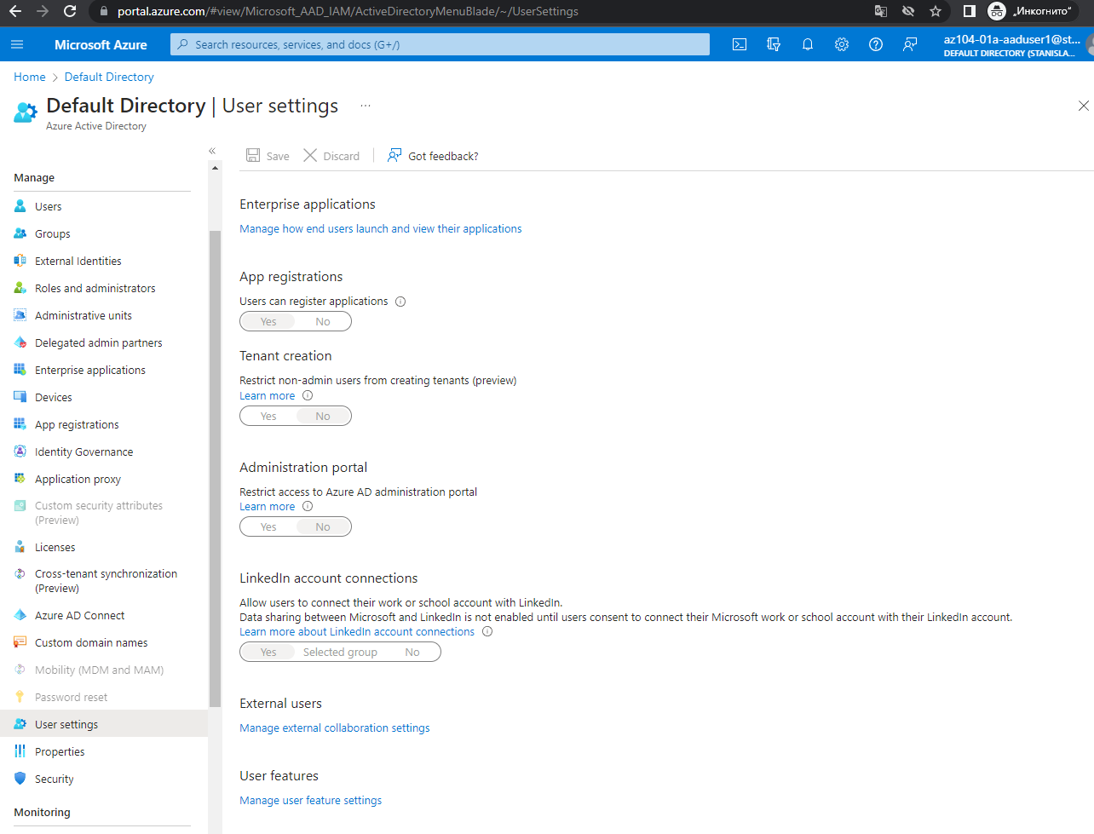

* + We don’t have a permission in the new account to change settings.
  + We are opening in private browser window and signing in to the Azure portal using the newly created user account. When prompted to update the password, we are changing the password to a secure password of your choosing.

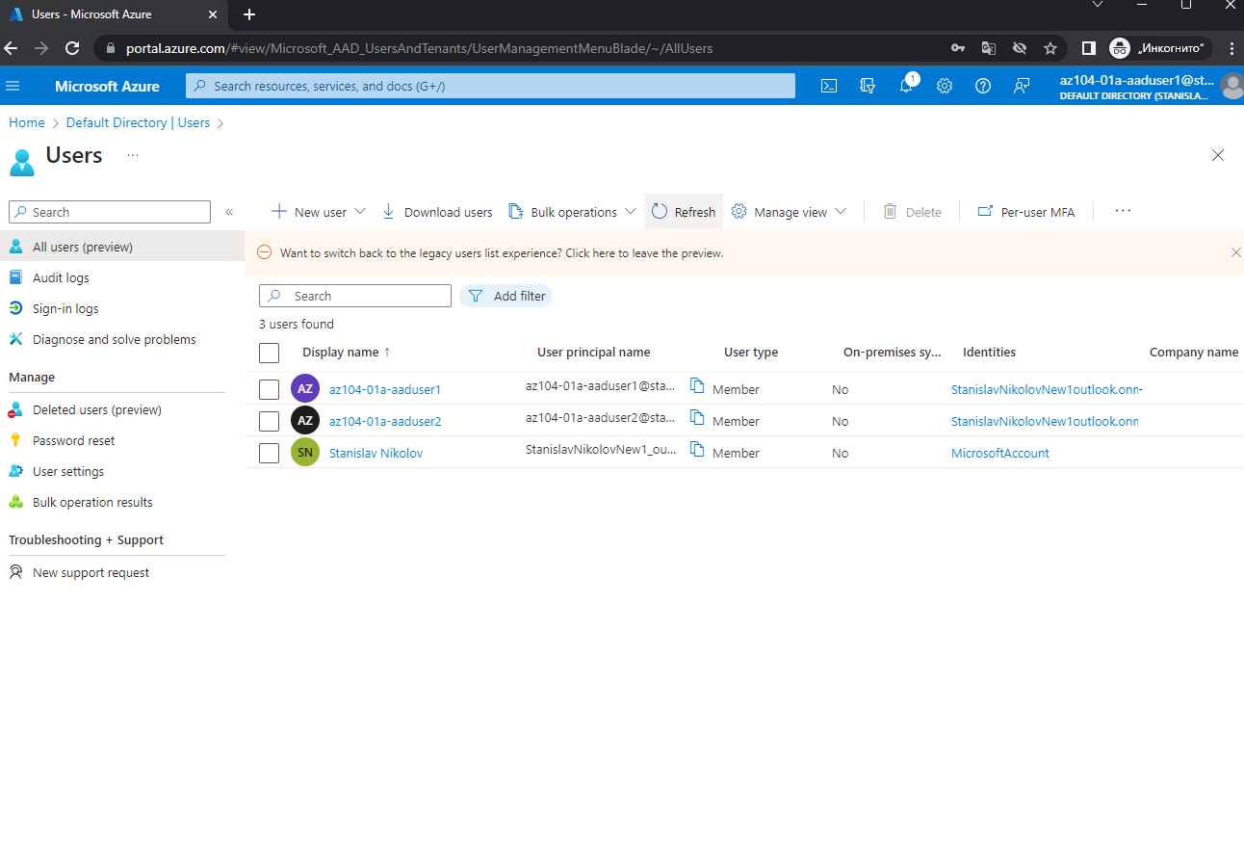

* + The creation of the second user.

In the private tab opened, and logged into the user1, we don’t have the right to change anything in User settings.

* Task 2: Create Azure AD groups with assigned and dynamic membership.
  + In this task, you will create Azure Active Directory groups with assigned and dynamic membership.

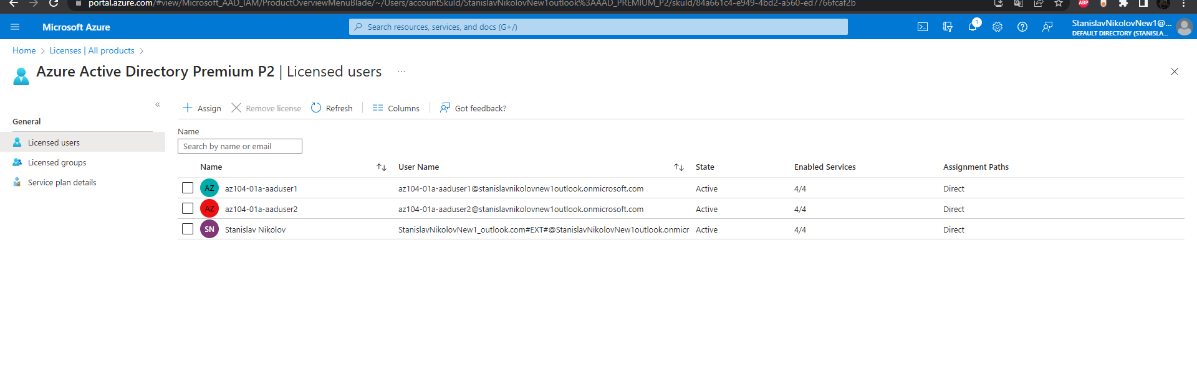

* + Trial license(that we add)

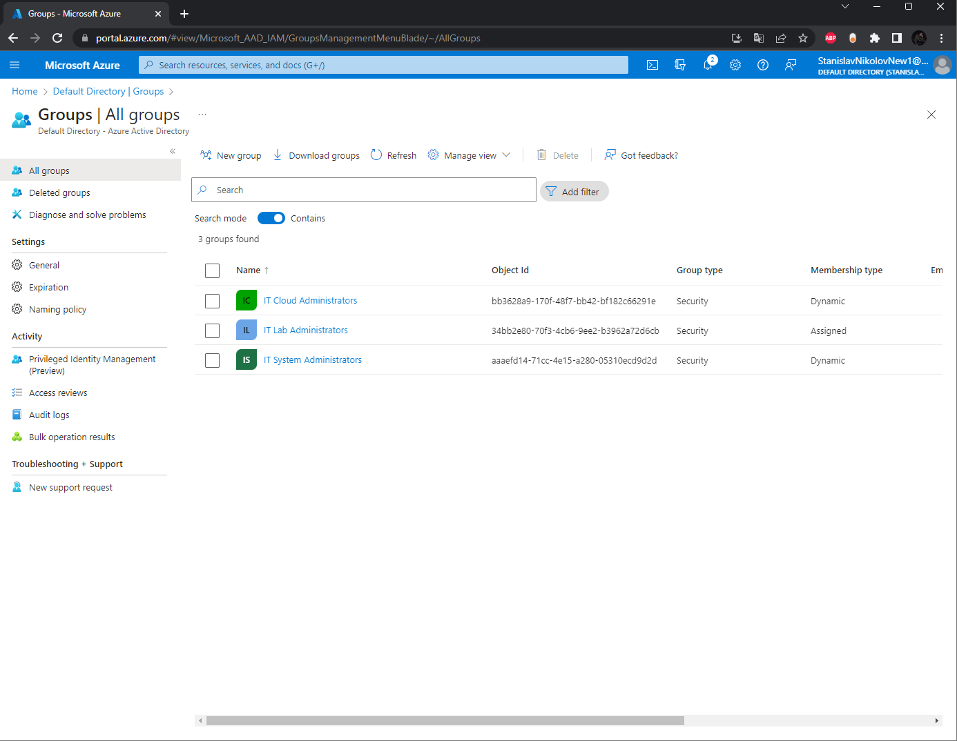

* + Creating all groups.

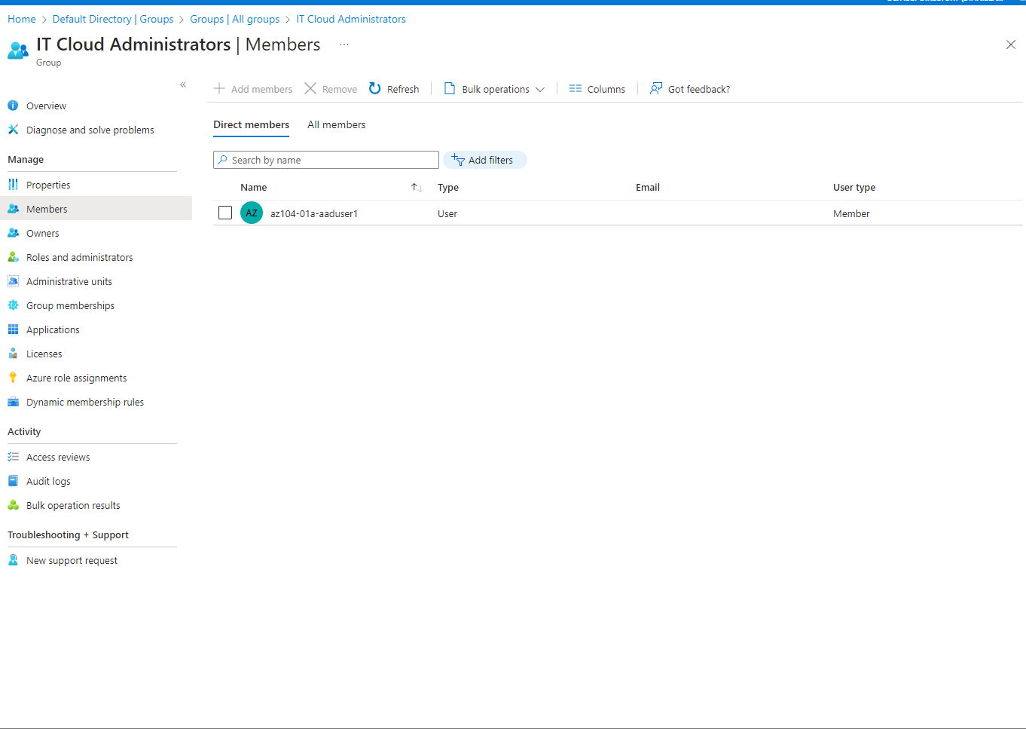

* + The users assigned to IT Cloud Administrators
* Task 3: Create an Azure Active Directory (AD) tenant (Optional - lab environment issue).
  + In this task, you will create a new Azure AD tenant.

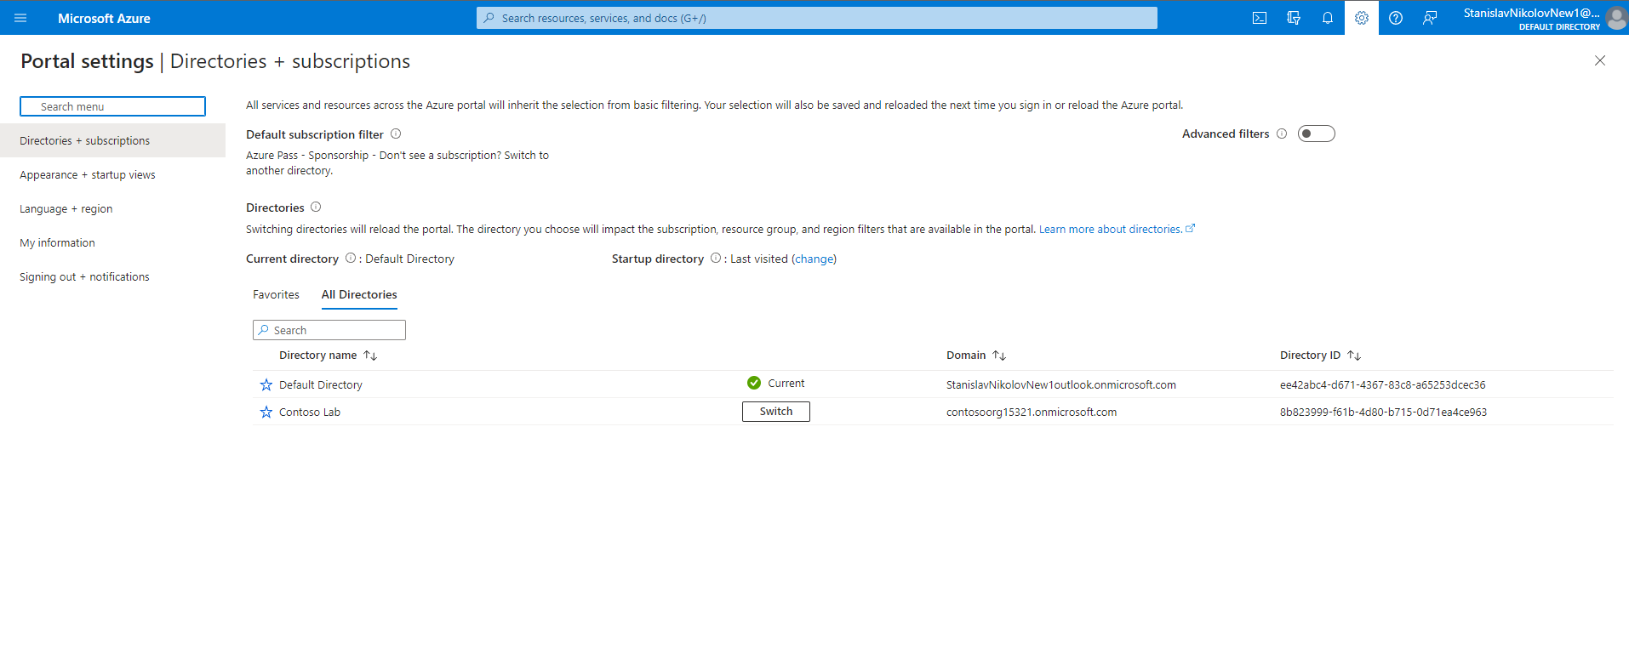

* + Creating the tenant Contoso Lab
* Task 4: Manage Azure AD guest users (Optional - lab environment issue).
  + In this task, you will create Azure AD guest users and grant them access to resources in an Azure subscription.

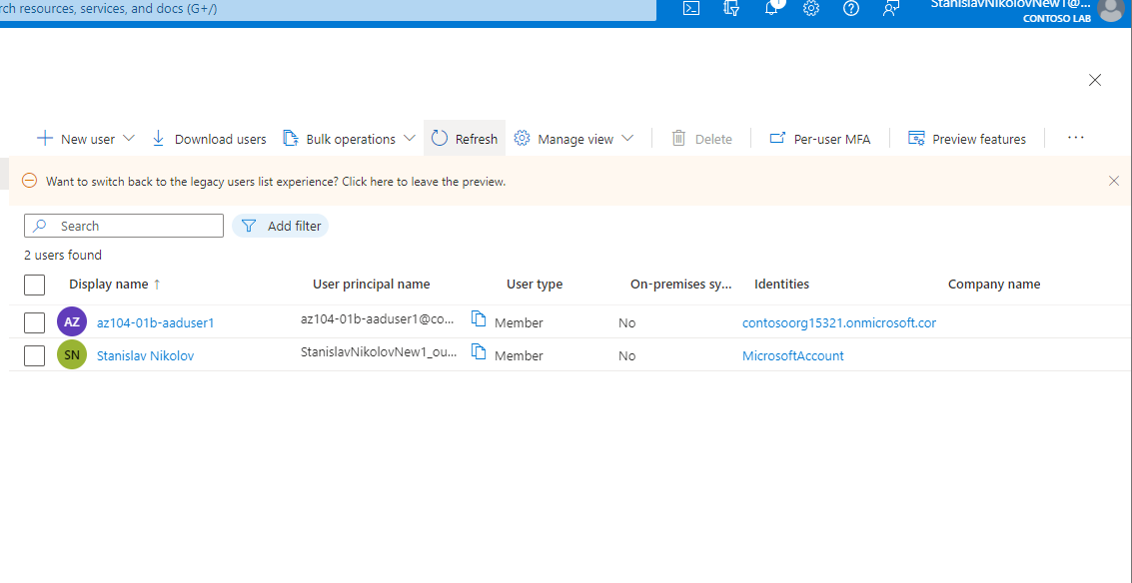

* + The created user in contoso, who we will invite.

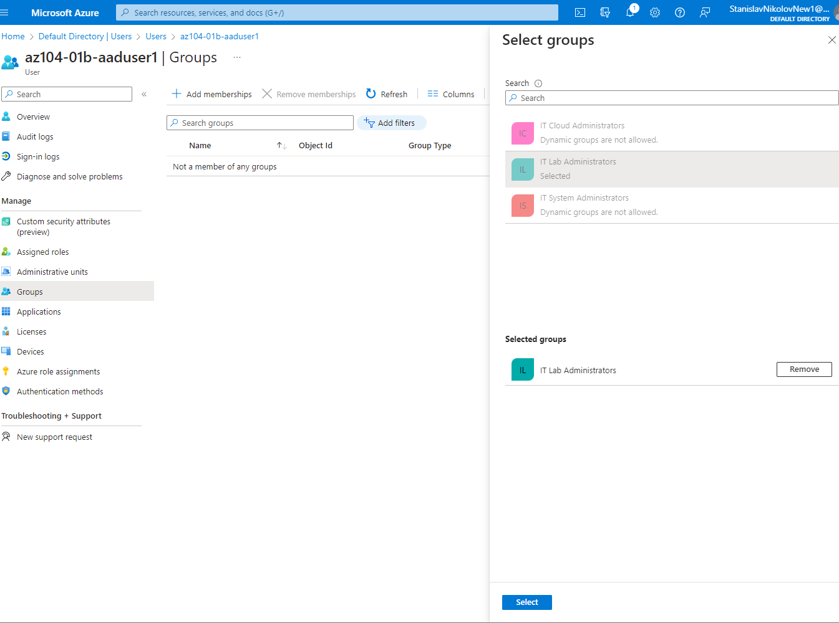

Add membership and add the guest user account to the IT Lab Administrators group.